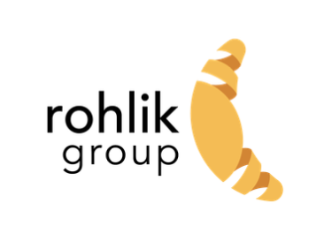

We are absolutely thrilled you are interested to join us at Rohlik Group. By now we have spoken to you about your experience and personality in great detail. The next step is to find out how you tackle a task in reality.

**First and foremost, we encourage you to ask any questions you feel are relevant to successfully tackle each of the problems, during the interview.**

**Head of Technical Programs**

**Problem 1: Peak Readiness Project Plan**

Rohlik experiences significant demand spikes during Christmas and Easter, with increases up to 5x normal levels. It's critical that all our services, including warehouse management systems, courier applications, customer-facing website and apps, and forecast models, can withstand this load. Your task is to drive and own the peak readiness project to ensure the highest possible availability of all our systems and a smooth peak season for our customers. For the case study, build a project plan for peak readiness that includes tasks, timelines, stakeholders, required inputs, and deliverables. Ensure your plan is clear, concise, and easy to comprehend. The objective is to develop a sound project plan to ensure all systems at Rohlik.cz can handle the increased demand during peak seasons (Christmas and Easter).

**Problem 2:**

The CTO group has defined a set of metrics to demonstrate the functioning or non-functioning of the IT department, including developer metrics, system performance and uptime, code quality, forecast model accuracy, analytical tooling performance, or data quality. Your task is to propose a framework (dashboards, analytics, regular review meetings, etc.) to gather, monitor, evaluate, and take action on these metrics to improve the performance and ROI of the IT organization. Present the development plan, draft dashboards, and processes to manage and optimize these metrics.

**Additional Information**

* Ask any questions you feel relevant to be able to crack each of the problems
* We will then go through the case study together during an interview, the case study presentation should not take more than 20 minutes.
* We are not strictly set on the form of the presentation. Whatever works for you and you are comfortable with, works for us. So if you just want to have an open forum discussion without any materials, we are in. If you want to present any documents to us, we will provide the tools for it or bring your own. Just let us know.